Idea Generation

Example,
Concept Name | Dr Punch
Genre | First person shooter (FPS)
Target Audience | Fast-paced action enjoyers, 15 – 30-year-olds
Concept Overview | You are in trouble. An enemy agency has sent their men to whack you in your lab after finding the cure for small hands. When hey invade you down the concoction and grow the most powerful firsts known to mankind. Use the layout to your advantage, deflect incoming bullets, and knock some science into them!
Core Mechanic | Deflecting bullets while punching
Inspiration(s) | Super-hot | How? | Using a similar combat mechanic without weapons. Visual style and enemy elimination will keep the game scope manageable & keep within the Pegi 12 rating
Inspiration(s) | Jonny English | How? | A goofy British atmosphere with slap stick comedy elements.
Sources | 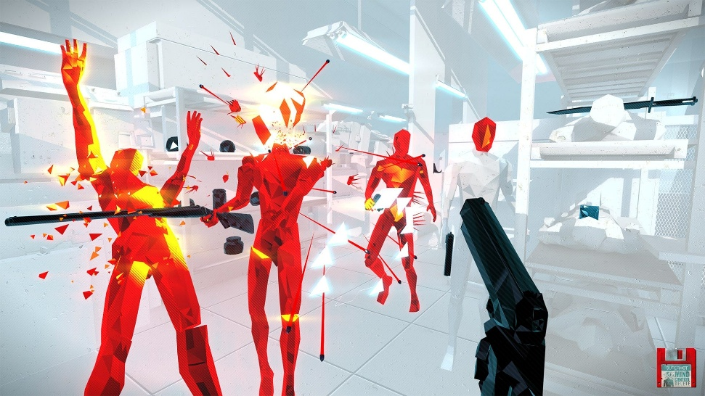  Super-Hot - https://superhotgame.com  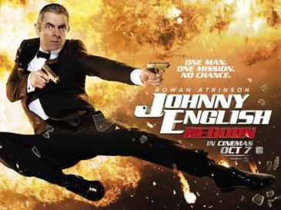  Jonny English - https://www.imdb.com/title/tt0274166/

Idea part one
Concept Name
Genre
Target Audience
Concept Overview
Core Mechanic
Inspiration(s) |  | How?
Inspiration(s) |  | How?
Sources

Idea part two
Concept Name
Genre
Concept Overview
Target Audience
Core Mechanic
Inspiration(s) |  | How?
Inspiration(s) |  | How?
Sources

Idea part three
Concept Name
Genre
Target Audience
Concept Overview
Core Mechanic
Inspiration(s) |  | How?
Inspiration(s) |  | How?
Sources

